Julie Nguyen

Homework 1, Kickstarter

July 29, 2018

**Conclusions to Kickstarter Data**

Theater is the largest category, comprising 34% of all campaigns, with 60% success rate. In general, artistic categories make up the bulk of campaigns, and are more likely to be successful than other categories. We can conclude that Kickstarter is a pretty good platform for getting artistic projects funded.

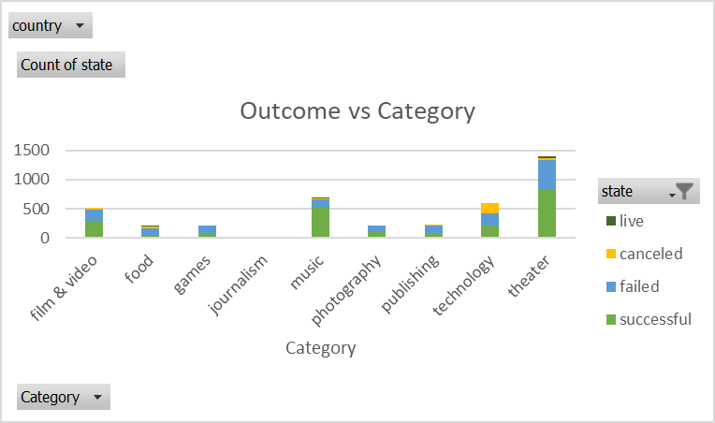

Tabletop games are much more likely to be funded than mobile and video games.

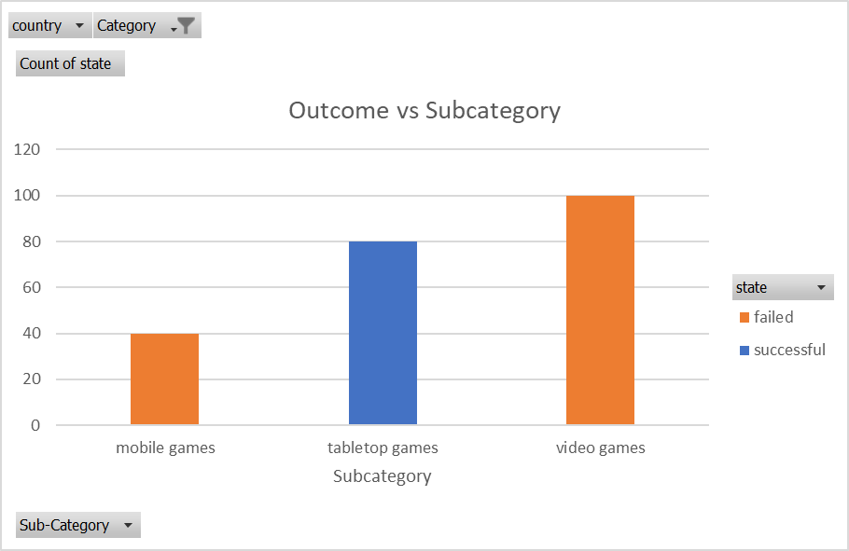

Rock and indie rock are the most popular music subcategories, together making 60% of all music submissions, and 74% of successfully funded music campaigns.

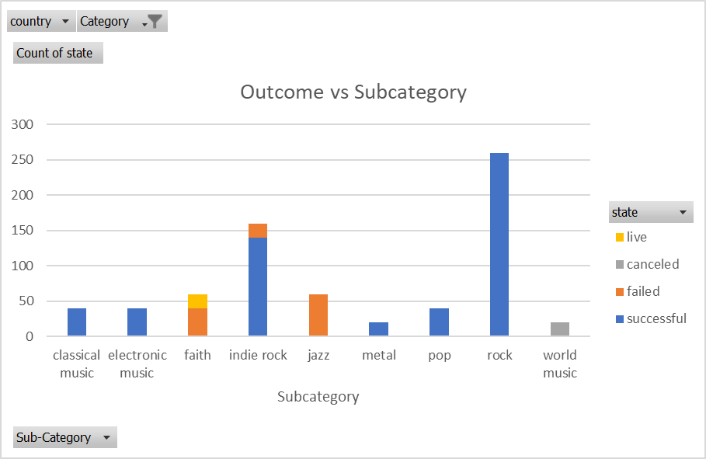

**Limitations**

In the bonus “Outcomes vs Goal,” the projects that needed less funding were more successful than projects that needed more funding. However, we did not convert currencies or adjust for purchasing power.

74% of campaigns are from the US, with other Western or English-speaking countries making up most of the rest. Any conclusions made based on this data may not apply to other parts of the world.

**Other analyses**

Kickstarter may have peaked in 2015, with smaller numbers of campaigns in 2014 and 2016. It is too early to tell, as only Q1 of 2017 is included in data. Are people tired of constant requests for money on social media?

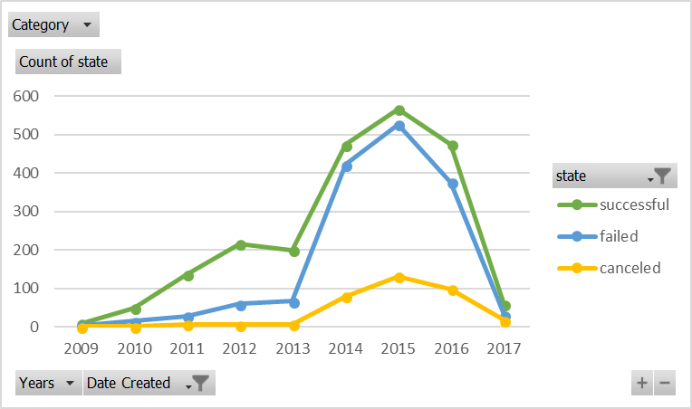

Staff picks give a big boost to campaigns. 53% of all campaigns were successful, and 87% of staff picks were successful

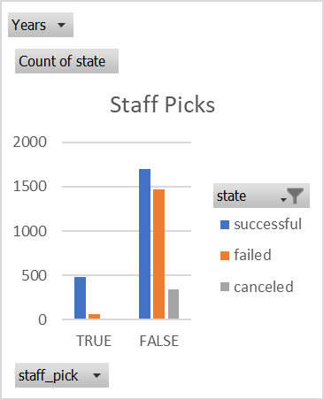

Faith music campaigns only date back to 2014, corresponding to the time Kickstarter became popular. In Q1 of 2017, we see 20 campaigns, which is equal to the entirety of 2015, and double the number for 2014 or 2016. While all faith music campaigns have failed, there is a jump in people asking for funding. Other subcategories of music do not see similar jumps. Is there renewed optimism in Christian-music makers after President Trump took office?

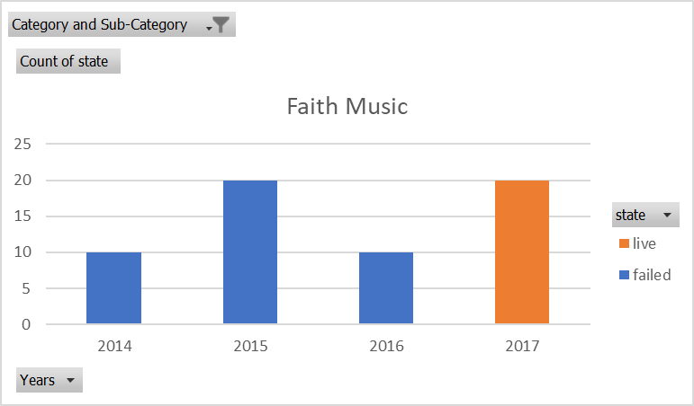

The data in “backers count” and “average donation” as-is could not be pivoted in Excel, due to the amount of unique values. The data from these columns could be categorized into discrete ranges, allowing us to create pivots with Excel. As of right now, we have not explored the relationship between donation amounts and the campaign outcomes.